#1
I am used for plant energy storage. I am made up of hundreds of glucose monomers.

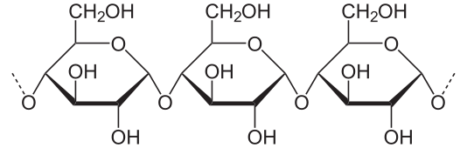

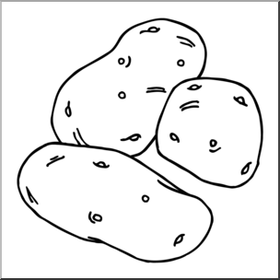
#2
I am used as chemical messengers. I consist of 4-fused rings. I have different properties depending on what molecules are attached to me.

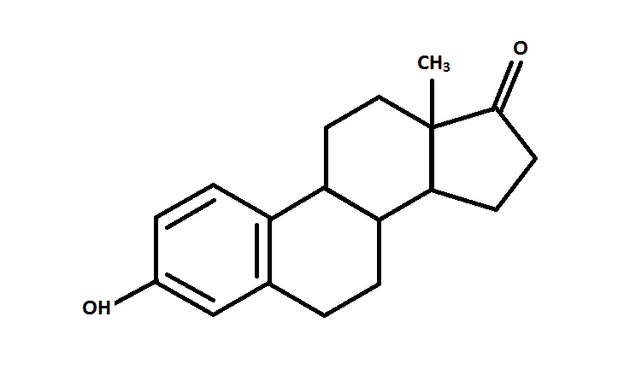

#3

I am used for plant cell wall structure. I keep the plant upright. When you eat me, you call it fiber.

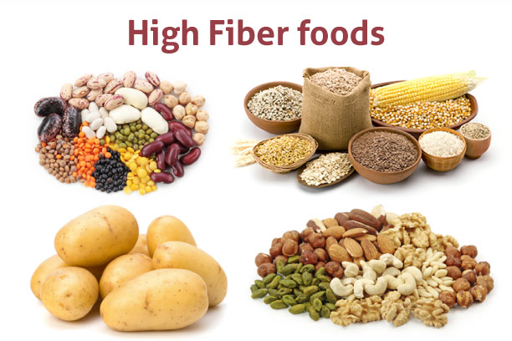

#4

There are 20 different versions of me. I am the monomer of polypeptides. Each one of me has a distinct “R” group that gives the property of the polymer its unique shape.

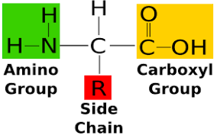

#5

I am used for energy storage in animals. I am found in the liver and muscle cells. I am a polysaccharide.

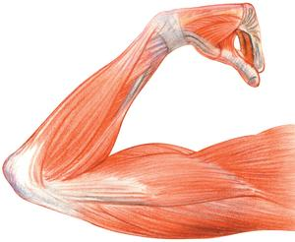

#6

I am found in the exoskeleton of insects. I make a “crunch”sound when stepped on.
I am a polysaccharide.

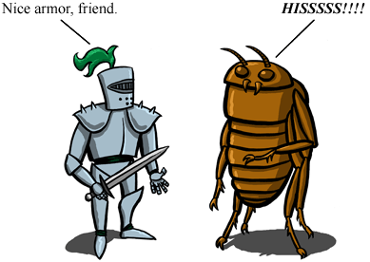

#7

I am solid at room temperature.

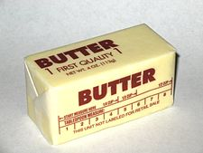

#8

I am liquid at room temperature

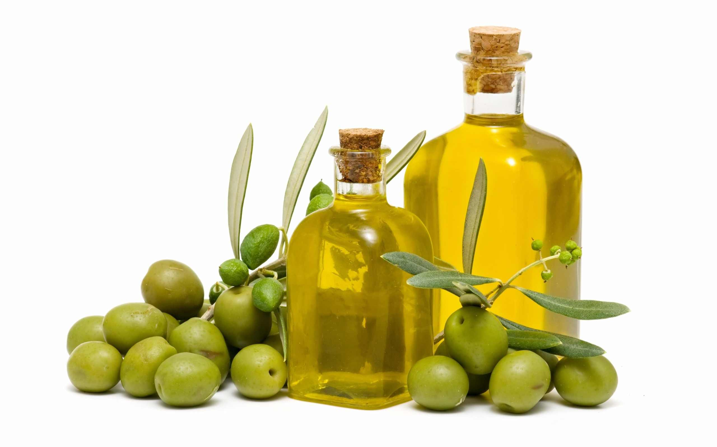

#9

I am part of a triglyceride. I can hold 3 fatty acids.

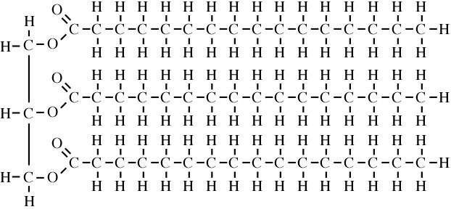

#10

I am used to catalyze chemical reactions. I reduce the energy of activation so reactions happen quickly. I have an active site that is unique to the substrate I work on.

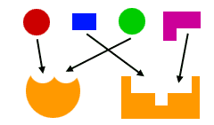

Name:__________________________

#1: starch

#2: sterols

#3: cellulose

#4: amino acid

#5: glycogen

#6: chitin

#7: saturated fat (triglyceride)

#8: unsaturated fat (triglyceride)

#9: glycerol

#10: enzymes

