Use the following website to complete the questions below: http://www.phschool.com/science/biology_place/labbench/lab1/concepts.html
- Define diffusion:

- Provide an example of diffusion:

- Osmosis is diffusion that involves the __________________ transport of _________________. In osmosis water moves through a _____________________________________________ from a region of __________________ concentration to a region of ________________________________ concentration.
- Play “Closer Look: Osmosis” Where is the water moving to? Why?

- True or False: The motion of each type of molecule is random and independent of other molecules in the solution.
- “Closer Look: Concentration Gradient” Compare the paragraph and video shown here to our diffusion lab. Explain what happened and why the starch in the baggie turned purplish.

- The movement of water is influenced by the _____________________________________ of the solution.
- Will there be a net movement of water between two isotonic solutions? ___________________
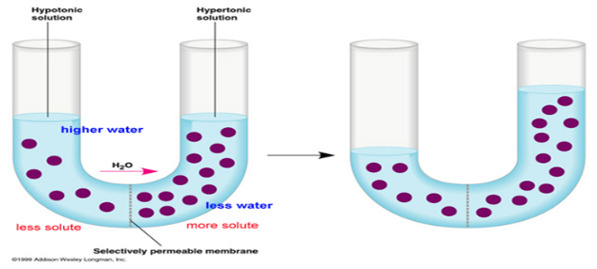
- Why don’t red blood cells pop in the bloodstream?

- In the picture to the right circle where the water concentration
Is greatest before osmosis.
- In the picture to the right, which test tube is at equilibrium? A B

Go to http://www.glencoe.com/sites/common_assets/science/virtual_labs/LS03/LS03.html and read “Under what conditions do cells gain or lose water?” to answer the following.
- A cell membrane permits some materials to pass through while keeping other materials out. Such a membrane is called ________________________________________________________.

- If the concentration of water molecules is greater outside a cell then the solution is _____________________ to the cell. Water will move ___________________ the cell by ____________________. The pressure against the inside of the cell membrane will steadily increase. If the pressure becomes great enough the cell membrane will __________________________.

- If a cell is living in a solution that has a higher salt concentration than the cell it is said to be a ___________________ solution.

Click and drag on the cell to cell how they react to different solutions. Draw the image below including arrows showing where the water is moving to.

Hypertonic

Isotonic

Hypotonic

Red Blood Cell:

Hypertonic

Isotonic

(Animal Cell)

Hypotonic

Elodea Cell:
(Plant Cell)

Hypertonic

Isotonic

Hypotonic

Paramecium:
(Protista)

Remember that SALT SUCKS! Water ALWAYS wants to move to where the HIGHEST solute concentration is and the LOWEST water concentration. Identify how the water will move in the solutions below and what type of solution it would be (Hypertonic, Isotonic, or Hypotonic)
25% water
25% water
82% Solute
53% Solute

80% water

____________________
25% water

_____________________
57% Solute

______________________
18% Solute

_____________________

