Name: ________________________________________________________ Date: ____________________
Honors Biology Midterm Exam Mastery Practice
Directions: Answer all of the following questions on a separate sheet of paper or in your spiral bound notebook.

- What are the functions of Carbohydrates?
- What are the functions of Lipids?
- What are the functions of Proteins & Enzymes?
- What does it mean to “denature” a protein such as an enzyme?
- Draw and label graphs comparing a reaction with and without the assistance of an enzyme.
- What are the functions of Nucleic Acids?
- Draw the cheat/hint for each of the macromolecules…like the “fat E” for lipids.
- Identify each of the following molecules.
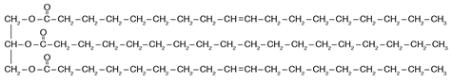

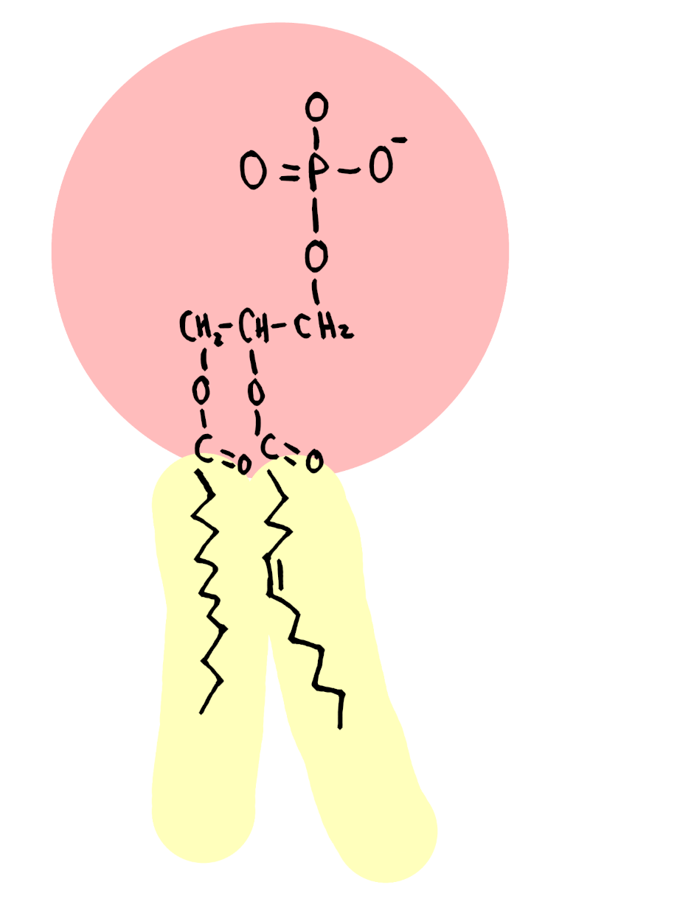
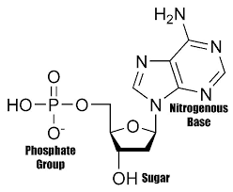
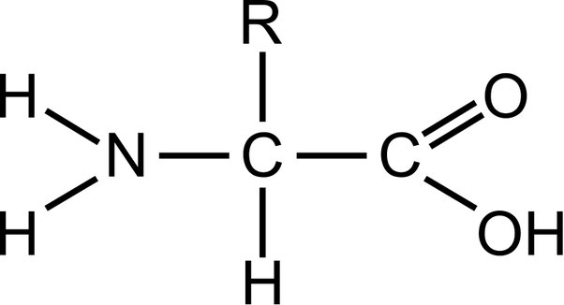
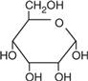

- Draw and label a pH scale. What is the job of a pH buffer?
- How are enzymes named? What do they all end in?
- What is the role of DNA in protein synthesis?
- What are the monomers/sub-units of each of the four macromolecules?
- Distinguish between organic and inorganic.
- Explain the statement that all compounds are molecules but, not all molecules are compounds.
- Draw and label an example of an enzyme aided dehydration synthesis reaction. Be sure to include the enzyme-substrate reaction.
- Explain what an organic catalyst is.
- Identify foods that contain a majority of
  - carbohydrates,
  - proteins,
  - lipids
- What is Chargaff’s rule?
- Compare a prokaryotic cell with a eukaryotic cell.
  - What are the structures found in a prokaryotic cell? *this should be a short list.
  - What is an example of a prokaryotic cell?
- Do animal cells have a cell wall…why or why not?
- Why do plant cells needs considerably more water than animal cells?
- Draw and label a cell membrane.
- What are the four indicator solutions that you need to know and describe a positive result for each test.
- Why do both mitochondria and chloroplasts have circular DNA? **think evolution and are they a part of the cells they live in?
- What is the role of each structure in protein synthesis?

  - Ribosome
  - DNA
  - mRNA
  - tRNA

- What is the function of the mitochondria?
  - What areas of the body require cells containing the greatest concentration of mitochondria? **Think what would need a lot of whatever mitochondria create.
- What is the role of a chloroplast?
- Fill in the following chart comparing the various forms of passive transport:

- Fill in the following chart comparing the various forms of active transport:
Endocytosis | Exocytosis
Pinocytosis:

Phagocytosis:

- Compare active v passive forms of transport…be sure to use the term concentration gradient.
- In class, we said that the sodium-potassium pump is the best example of active transport. Describe what occurs during this form of transport and justify why it is such a good example. What types of cell utilize this very specific transport protein?
- Given a DNA strand of ATA CGC CAT TAG GGG CTA, what would be the complementary strand?
- What model shape did Watson and Crick build that won the Nobel? Whose work did they use/steal to build that model?
- What are the two strands of DNA called…how can you tell them apart?
- Fill in the blanks in the following chart:
DNA
mRNA | AUG AGG CAC GGG AUA UAG
Amino Acid
tRNA

- What is the name for three consecutive bases on a strand of DNA, mRNA and then for tRNA?
- How many forms of RNA are there, name each and state it’s function in the process of protein synthesis?
- Compare and contrast transcription and translation.
- Compare and contrast DNA and RNA.
- What is the difference between a doubled chromosome and a single chromosome? What is chromatin? What is another name for a double chromosome?
- Describe the process of glycolysis. What is the net gain of ATP using glycolysis?
- What is more beneficial aerobic respiration or anaerobic respiration?
- What are the three forms of anaerobic respiration?
- What are the different steps involved aerobic respiration? How much ATP is made during each step and what is the total amount of ATP made during aerobic respiration?
- Draw and label a chloroplast…include information about structures and the chemical reactions involved in photosynthesis.
- What factors can influence the rate of photosynthesis?
- Draw and label a mitochondrion…include information about structures and the chemical reactions involved in aerobic cellular respiration.
- What are the balanced equations for photosynthesis & aerobic cellular respiration?
- Define the following terms: mutation, mutagen, & carcinogen.
- Compare gene mutations and chromosomal mutations.
- What is the worst kind of mutation?
- How does a mutation impact the process of protein synthesis?
- What are the four parts of interphase?
- What the four steps of mitosis called?
  - What do the roots in the word prophase mean?
  - “ “ metaphase?
  - “ “ anaphase?
  - “ “ telophase?
- Why do cells have to be so small?
- Distinguish between the cytokinesis of animal cells and plant cells?
  - Why are they different?
- Fill in the chart below:
Type of asexual reproduction | Description | Type of organism
Budding
Fragmentation/Regeneration
Mitosis
Sporulation
Vegetative Propagation

- What disease is a result of uncontrolled cellular division?
- Draw an animal cell during each of the phases of mitosis and describe what is happening to the cell during each phase.
- What do the letters STERNGRR stand for and what information are they trying to convey?
- Is fire alive, why or why not?
- How do you correctly write a hypothesis statement?
- Compare a dependent variable v independent variable.
- What are experimental constants?

