Who was Gregor Mendel?

Gregor Mendel’s Laws
Gene-Chromosome Theory (not really Mendel’s) | Law of Dominance (complete dominance) | Law of Segregation  (of alleles) | Law of Independent Assortment
Hereditary information is transmitted from parents to offspring as genes found on chromosomes. These genes determine an individual’s traits. | In cases in which two or more forms (alleles) of a gene for a single trait exist, some forms of the gene may be dominant and cover up others that are recessive. | In most sexually reproducing organisms, each adult has 2 copies of each gene: one from each parent. These genes are segregated from each other when gametes are formed. | The alleles for different genes usually segregate independently of one another.

Dominant Alleles vs. Recessive Alleles
H
- The dominant allele always Hides or masks the recessive allele. It is the one that is shown and it is what we see
Hh
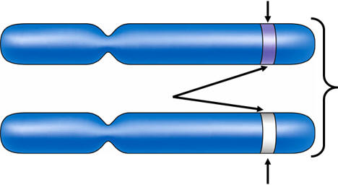

    - Dominant alleles are represented with capital letters.
h

- The recessive allele is “weaker” and gets covered up by the dominant allele. It is not expressed unless an individual inherits 2 copies of the alleles.
    - Recessive alleles are represented with lowercase letters .

Gregor Mendel studied pea plants. The data below represents his findings
Dominant Traits: tall stems, green pods, yellow seeds, round seeds
Recessive Traits: short stems, yellow pods, green seeds, wrinkled seeds

Trait | Height | Pod Color | Seed Color | Seed Shape
Dominant | T | G | Y | R
Recessive | t | g | y | r

Genotype | Phenotype
- The use of letters to represent the alleles for a trait is called an organism’s  - Examples: TT = Tall plant, gg =yellow pod, Yy = yellow seeds | - The expression of those alleles (or traits) is called an organism’s  - Examples: tall or short plant, green or yellow pod
When alleles are brought together in fertilization, they are classified according to which allele matched with another.

Homozygous | Heterozygous
- When an organism has 2 of the same alleles (either dominant or recessive), they are said to be true-breeding or homozygous.  (homo = same)  - Examples: TT, GG, gg, yy, RR | - When an organism has 2 different alleles (one dominant, and one recessive), they are said to be hybrid, or heterozygous.  (hetero = different)  - Examples: Gg, Rr, Yy

Guided Practice
- For each genotype below, indicate whether it is heterozygous (He) or Homozygous (Ho).
  - TT __Ho_____ b. Bb _He___ c. Dd _He____ d. LL _Ho____ e. gg __Ho_____
  - Circle the genotypes above that would be considered purebred.
  - Draw a square around the genotypes above that would be hybrids.
- Determine the phenotype for each genotype using the information provided.
  - Brown hair is dominant to blonde hair. e. Brown eyes are dominant to blue eyes.
    - BB ___Brown_____________ i. BB _____Brown________________
    - Bb ___Brown_____________ ii. Bb __________Brown_____
    - bb ___Blonde____________ iii. bb ____Blue_________
  - Which genotype is homozygous brown? _BB__
  - Which genotype is homozygous blonde? _bb_
  - Which genotype is heterozygous? _Bb__
- For each phenotype, give the genotypes that are possible.
  - Tall plants (T) are dominant to short plants (t). b. Purple (P) flowers are dominant to white flowers (p).
    - Tall = __TT,Tt_______________ i. Purple = ____PP, Pp______________
    - Short = ____tt _______ ii. White = _____pp________________

