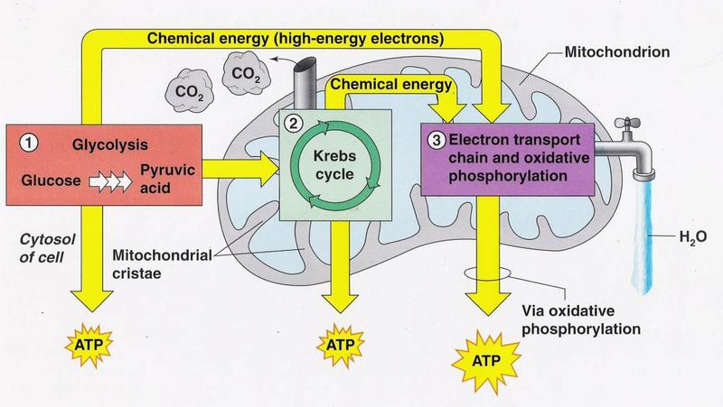
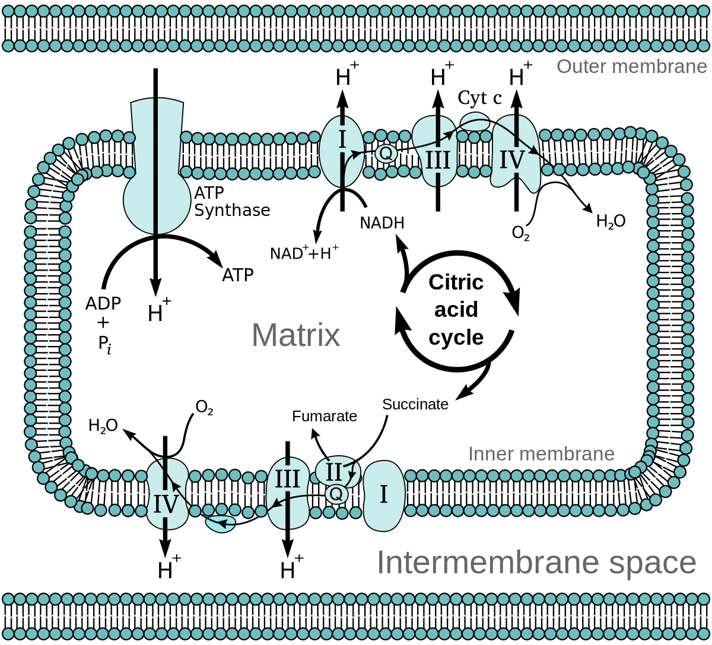
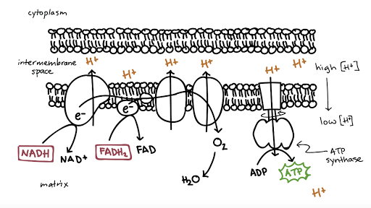

Krebs Cycle Chemical Energy (High Energy Electrons)
Glycolysis Cristae
ATP Glucose
H₂0 Cytosol of cell
CO₂ Chemical Energy
Pyruvate Electron Transport Chain/Oxidative Phosphorylation
Pyruvic Acid
VIA oxidative Phosphorylation

