He Helped Discover Evolution, And Then Became Extinct
April 30, 2013 3:04 AM
7 min 46 sec
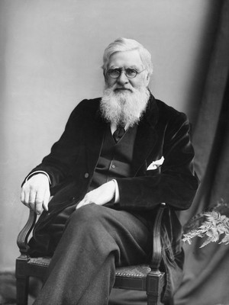
The research of British naturalist Alfred Russel Wallace (1823-1913) played a pivotal role in developing the theory of natural selection. But over time, Charles Darwin became almost universally thought of as the father of evolution.
Hulton-Deutsch Collection/Corbis
Ask most folks who came up with the theory of evolution, and they'll tell you it was Charles Darwin.
In fact, Alfred Russel Wallace, another British naturalist, was a co-discoverer of the theory — though Darwin has gotten most of the credit. Wallace died 100 years ago this year.
Wallace developed some of his most important ideas about natural selection during an eight-year expedition to what was then the Dutch East Indies — modern-day Indonesia — to observe wildlife and collect specimens. Few places on earth can rival this vast archipelago's tremendous diversity of plant and animal life.
Wallace collected more than 100,000 insect, bird and animal specimens, which he gave to British museums.
By 1855, Wallace had come to the conclusion that living things evolve. But he didn't figure out how until one night three years later. He was on the island of Halmahera, ill with a fever, when it came to him: Animals evolve by adapting to their environment.
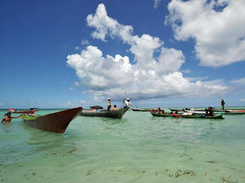
As soon as he could, Wallace wrote his theory down in a closely argued, eight- or nine-page paper, says Tony Whitten, a Wallace expert with British-based Flora & Fauna International.
"He sent that to Darwin, as an older mentor, if you like, to have a peer review before publication," Whitten says.
Darwin had reached the same conclusion years earlier, and Wallace's letter spurred him to act. The two men published a joint paper in 1858, arguing the theory of evolution and natural selection. It shook mankind's assumptions about its origins, which were heavily influenced by religion.

Fishermen arrive on Wakatobi island in Sulawesi waters off eastern Indonesia in 2009. In the 19th century, the island's rich and unique biodiversity helped Wallace understand how species adapted to their environment — and how regions are defined by the animals that live in them.
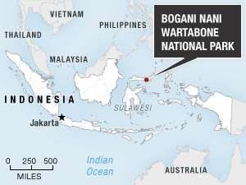
Aek Berry/AFP/Getty Images
The following year, Darwin published his book and rose to fame. Wallace, ultimately, faded into obscurity.
Sulawesi And Survival Of The Fittest
But at the time, Wallace was still refining his ideas about natural selection — and had landed on what is now Indonesia's island of Sulawesi, a place where most of the animals there existed no place else on earth.
Today, Sulawesi's natural abundance has been severely depleted. Many of its unique species are close to extinction in the wild, found only in nature preserves.
The high point for Wallace's explorations on Sulawesi was the search for a bird called the maleo, which exists in nature only on the island.
In Wallace's footsteps, I recently went in search of the bird at the Bogani Nani Wartabone National Park. I walked through a dense, misty highland forest, full of luxuriant fan palms and bubbling hot springs, amid the constant chatter of birds and insects.
At one point, we spotted two male maleos, calling to their mates, with an eerie, trilling sound. The birds are somewhere between a chicken and a turkey in size, with black feathers and a salmon-colored breast.

Credit: Alyson Hurt/NPR
In his book The Malay Archipelago, Wallace wrote that students of natural history should avoid thinking of animal behavior as "fixed points." He argued that this has "the bad effect of stifling inquiry into the nature and causes of 'instincts and habits.' " Wallace's insatiably curious mind was constantly thinking about how animals' behavior reflected their changing natural surroundings.
For example, Wallace observed that maleos have adapted so perfectly to the environment that they even use Sulawesi's geology to survive. Instead of sitting on their eggs like hens, maleos use geothermal energy to incubate them. They dig into the earth, which is heated by hot springs. They can sense where the temperature is just 86 to 97 degrees, and that's where they lay their eggs.
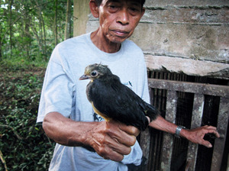
At the park's hatchery, ranger Max Lela showed us a downy, three-day-old maleo chick. We could see that unlike other species similar to it, the maleo has webbing between three of its claws. Wallace believed that maleos had developed this webbing to help them dig into the earth and bury their eggs.
Lela says that after eight weeks, the buried eggs hatch and the maleo chicks struggle up through the dirt and immediately fly away. That keeps them safe from local predators such as the monitor lizard.

Poacher-turned-conservationist Karamoy Maramis, who works at Bogani Nani Wartabone National Park in Sulawesi, holds a maleo, a bird that exists in nature only on the Indonesian island.
Rebecca Davis/NPR
"After reaching the surface, they will stop and then shake their wings and body because they are covered with dirt," Lela says. "But then they can walk and fly right away, without any parental training."
Lela puts the little chick in my hand. It wobbles for a second, and then flies off into a nearby tree — no small feat for a three-day-old bird.
Discovering 'Wallacea'
Perhaps Wallace's greatest contribution to the theory of natural selection was simply to ask: Why do we find this animal in this place?
He realized that just as animals are shaped by where they live, regions can also be defined by the animals that live there.
He noticed, for example, that the maleo is related to species found in Australia, but not in Asia, not even on the island of Borneo just a few miles to the west. Even non-experts may observe that there are no elephants or rhinoceroses in Australia, and no kangaroos or koalas in Asia.
Whitten, Fauna & Flora International's Asia-Pacific regional director, says Wallace concluded that Sulawesi was located on some sort of boundary line that separates different biological regions.
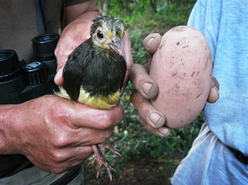
Maleos are a prime example of an animal that has adapted to its environment, using geothermal energy to incubate their eggs rather than body heat. They dig into the earth, which is heated by hot springs, are able to sense spots that are exactly 86 to 97 degrees, and lay their eggs there.
Rebecca Davis/NPR
"Clearly this was a transition between the Asian world and the Australian world," Whitten says. "And so came the thought of this line that could be drawn between Borneo and Sulawesi, that would separate the Asian fauna from the Australian fauna."
Wallace didn't know it at the time, but that line is actually the divide between two continental shelves. The line is now called the Wallace Line, and the transitional region around it is called Wallacea.
Wallace believed that Sulawesi is unique because most of the animals that live here are not found anywhere else on earth.
He concluded that these animals had been on this island isolated from other species for a very long time, and slowly evolved into new species.
Sulawesi naturalist John Tasirin says that Wallace found that 64 percent of mammals on Sulawesi are unique to the island. However, if you subtract bats — which are highly migratory mammals — from that figure, it jumps to 86 percent.
Tasirin says that Wallace saw the island's natural history in terms of how species had migrated to new environments on the island, adapted to them, and then evolved.
"You can see the movement of the animals. And when they move, suddenly they become a new species," Tasirin says, adding that it's not exactly "suddenly" but more like 3,000 or 6,000 years.
Foretelling Future Threats
Biodiversity provides the raw material for natural selection to work on. It also allowed Wallace to compare and contrast the differences among many species — differences as subtle as the graceful curve of a butterfly's wing.
Whitten says Wallace marveled at the variety of life on earth, even as he mourned man's effect on it.
"He just wondered how could it possibly be that ... we celebrate creation, in whatever way you want to understand that, and yet destroy it at the same time; [and that] just was so awful that we should all work to try to conserve that biodiversity," Whitten says.
As Wallace's eyes observed life around him, his mind roamed millions of years back in time, to imagine the birth of islands and continents. He also peered into the future. Back in England in 1863, he wrote:
"Future ages will certainly look back on us as a people so immersed in the pursuit of wealth as to be blind to higher considerations."
Wallace foretold today's situation, in which Sulawesi's unique animals face extinction. He wrote that we have it within our power to save these creatures, and not let them, as he put it, "perish irrecoverably from the face of the earth, uncared for and unknown."
http://www.npr.org/2013/04/30/177781424/he-helped-discover-evolution-and-then-became-extinct?sc=17&f=1001

