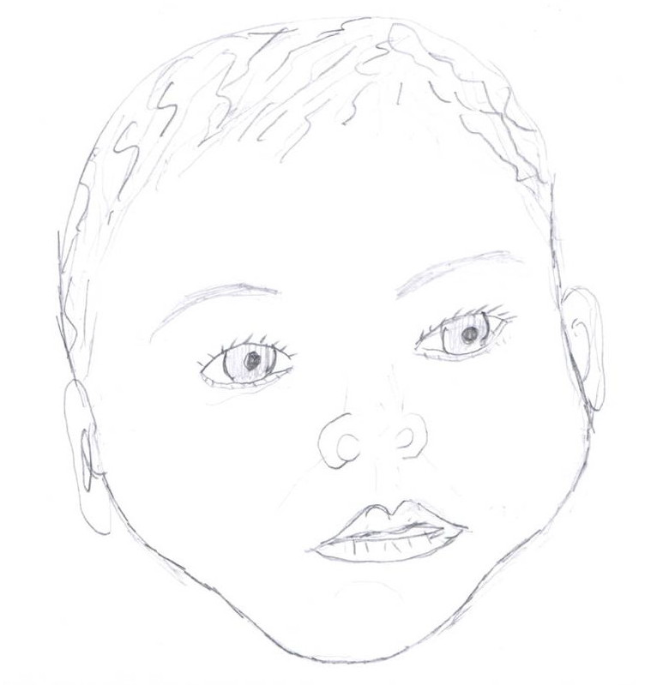
Create a Baby Lab Artwork by Maria Rascon
Purpose: To demonstrate the principles of Mendelian genetics and sex determination, including the concepts of allele, phenotype, genotype, dominant, recessive, codominant, homozygous and heterozygous by creating a simulated baby.
Table 1: Check here indicating whether you are the mom or the dad and fill in the data below.
Mom’s Name: _______________ Dad’s Name: ________________ Baby’s Name:__________

Trait | Heads | Tails | Allele from Mom | Allele from Dad | Genotype | Phenotype
Gender | X | Y | ______X______ | _____________ | _____________ | _____________
Face Shape | R | r | _____________ | _____________ | _____________ | _____________
Chin Shape | N | n | _____________ | _____________ | _____________ | _____________
Chin Dimple | A | a | _____________ | _____________ | _____________ | _____________
Freckles | F | f | _____________ | _____________ | _____________ | _____________
Cheek Dimples | D | d | _____________ | _____________ | _____________ | _____________
Lip Thickness | T | t | _____________ | _____________ | _____________ | _____________
Eye Brows | B | b | _____________ | _____________ | _____________ | _____________
Eye Shape | W | w | _____________ | _____________ | _____________ | _____________
Eyelashes | L | l | _____________ | _____________ | _____________ | _____________
Ear Shape | R | r | _____________ | _____________ | _____________ | _____________
Ear Lobes | F | f | _____________ | _____________ | _____________ | _____________
Widow's Peak | W | w | _____________ | _____________ | _____________ | _____________
Hair Curliness | C₁ | C₂ | _____________ | _____________ | _____________ | _____________
Eyebrow Color | D₁ | D₂ | _____________ | _____________ | _____________ | _____________
Eye Width | W₁ | W₂ | _____________ | _____________ | _____________ | _____________
Eye Size | S₁ | S₂ | _____________ | _____________ | _____________ | _____________
Mouth Size | M₁ | M₂ | _____________ | _____________ | _____________ | _____________
Nose Size | P₁ | P₂ | _____________ | _____________ | _____________ | _____________
Birth Mark | B₁ | B₂ | _____________ | _____________ | _____________ | _____________
Skin Tone | S₁ | S₂ | _____________ | _____________ | _____________ | _____________
Polygenic Trait | (4 coin flips) |  | Alleles from Mom | Alleles from Dad | Genotype | Phenotype
Hair Color | A, B | a, b | #1____ #2____ | #1____ #2____ | __ __ /__ __ | _____________
Eye Color | A, B | a, b | #1____ #2____ | #1____ #2____ | __ __ /__ __ | _____________

Concluding Questions:
1. Why is the coin flip used to represent the selection of alleles?
2. Define the following terms:
allele-
phenotype-
genotype-
dominant-
recessive-
codominant-
homozygous-
heterozygous-
chromosome-
locus-
gene-

