Evidences for Evolution Worksheet

**Fossils**

This is a series of skulls and front leg fossils of organisms believed to be ancestors of the modern-day horse.

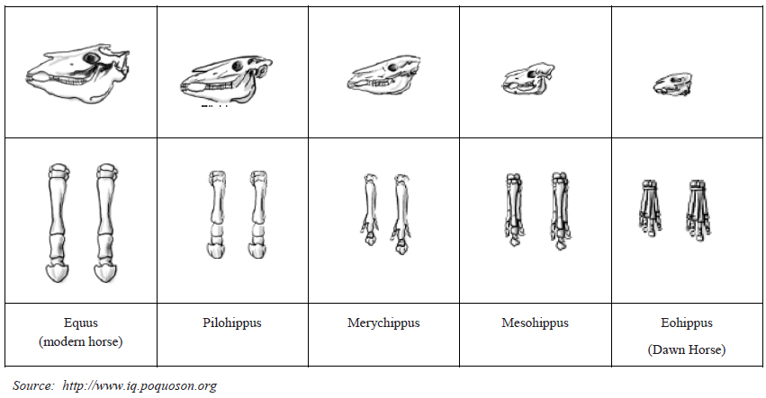

1. Give two similarities between each of the skulls that might lead to the conclusion that these are all related species.

a. ______________________________________________________________________________________________

b. ______________________________________________________________________________________________

2. What is the biggest change in skull anatomy that occurred from the dawn horse to the modern horse?

3. What is the biggest change in leg anatomy that occurred from the dawn horse to the modern horse?

**Embryology**

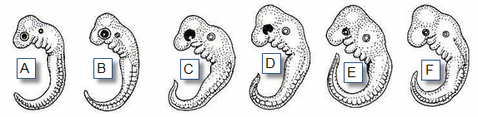Organisms that are closely related may also have physical similarities before they are even born!

4. Take a look at the six different embryos below. Hypothesize which embryo is from each of the following organisms. Record your answers on chart to the right.

5. Hypothesize which embryo is from each of the following organisms. Record your answers on chart to the right of the image.

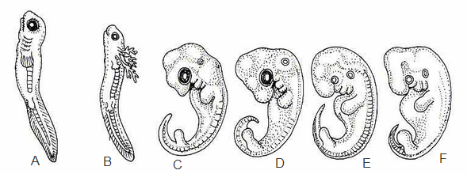

These are the embryos at their most advanced stage, shortly before birth.

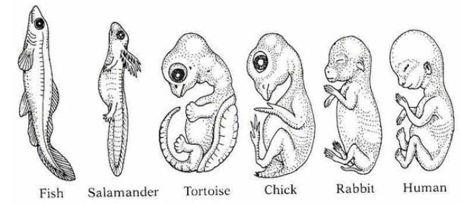

6. Look again at the six embryos in their earliest stages. Describe the patterns you see. What physical similarities exist between each of the embryos?

7. Does this suggest an evolutionary relationship? Explain how these embryos can be used as evidence of a common ancestor between each of these six organisms.

**Comparative Anatomy**

8. Define each of the following terms:

a. Homologous Structures:

b. Analogous Structures:

c. Vestigial Structures:

9. Shown below are the images of the skeletal structure of the front limbs of 6 animals: human, crocodile, whale, car, bird, and bat. Each animal has a similar set of bones. Color code each of the bones according to this key:

**Humerus:** Red **Ulna:** Orange **Radius:** Yellow **Carpals:** Green **Metacarpals:**Blue **Phalangs:** Purple

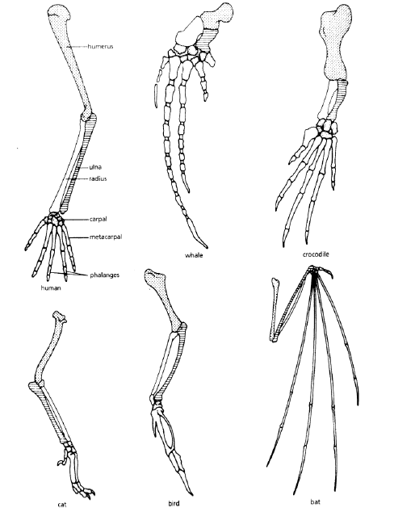

10. Circle the correct term: This is an example of (homologous, vestigial, anatomical) structures.

11. Compare the anatomy of the butterfly and bird wing

1. What is the function of both structures?
2. How are they different in form?
3. . Circle the correct term: This is an example of (homologous, vestigial, anatomical) structures.

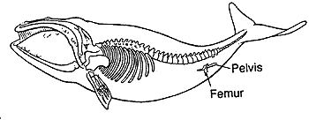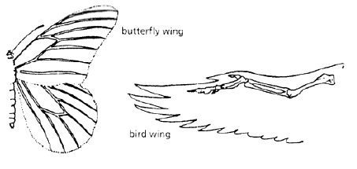

12. The image to the right represents __________________________structures

**Biochemical**

13. Biochemical similarities also provide evidence for evolution. The chart below shows similarities in amino acid sequences in hemoglobin for several species. Highlight any amino acid that differs from the human sequence. (it may help to use a different color for each animal)

|  |  |  |
| --- | --- | --- |
| **Species comparison** | **# similarities** | **# differences** |
| Human/Chimpanzee |  |  |
| Human/ Gorilla |  |  |
| Human/ Rhesus monkey |  |  |
| Human / Horse |  |  |
| Human/ Kangaroo |  |  |

a. According to the information in the chart, which species have the closet relationship to humans? _________________ b. Which species is least related to humans? ____________________