Cell Membrane and Transport Study Guide

1. Draw and describe the structure of the plasma membrane (include phospholipids and proteins). Define Selective or Semi Permeable.

2. Describe the function of proteins in the plasma membrane.

3. What is the difference between active and passive transport through a membrane? Why does active transport require energy, while passive transport does not?

4. What are the three types of passive transport and what is the difference between them?

5. What is osmosis?

6. Look at the following scenarios and state whether water will move into or out of the cell. Using the terms cytolysis and plasmolysis, apply them to the correct scenario.

A.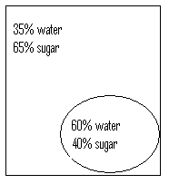 B. 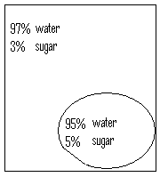 C. 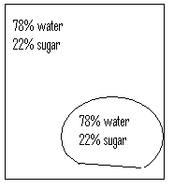

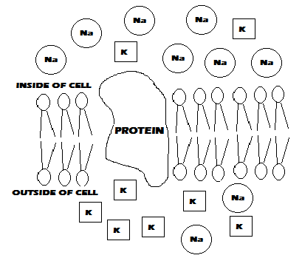
7. Answer the following questions based on the diagram below.

A. What type of transport moves the sodium (Na) particles from inside the cell to outside?

B. What type of transport moves the potassium (K) particles from inside the cell to outside?

C. Which movement requires energy?

D. Which substance must move through the protein?

8. For each diagram, state whether the cell is HYPOTONIC, HYPERTONIC, or ISOTONIC.
(Hint: Look at the direction of water movement – is water moving in, moving out, or moving IN and OUT)
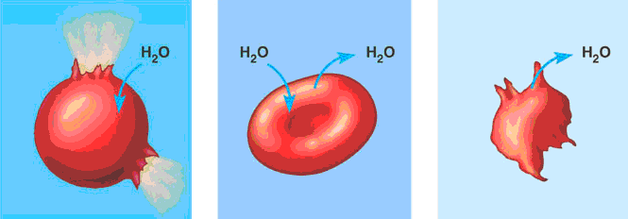
____________ ____________ ____________

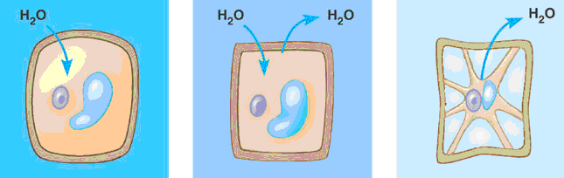
____________ ____________ ____________

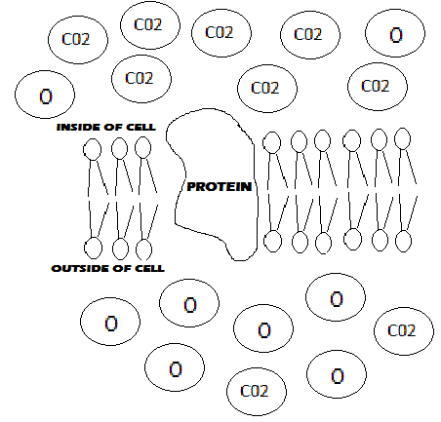
9. The diagram to the left shows the concentrations of oxygen (O) and carbon dioxide (CO2) around a cell. Both of these molecules will move through the membrane via passive transport, simple diffusion. Explain the direction of movement (in or out) for both the oxygen and carbon dioxide.

- Oxygen:

- Carbon Dioxide:

10. If sugar is actively pushed into a cell where there is already a high concentration of sugar, what type of cell transport is occurring?
a. diffusion b. active transport c. passive transport d. facilitated diffusion

11. Active transport is used to move sugar molecules into liver cells for storage. Which of the following explanations explains why active transport would be used instead of passive transport?
a. the concentration of sugar in the liver is less than in the blood
b. sugar molecules are not normally found in the liver
c. the concentration of sugar in the liver is greater than in the blood
d. sugar is highly toxic to liver cells
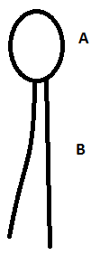

Analyze the following diagram of the phospholipid and answer the questions below:

12. What part of the phospholipid (A or B) is hydrophobic?

13. Which part of the phospholipid (A or B) is hydrophilic?

Fill in the blanks of the following using HYPOTONIC, HYPERTONIC, or ISOTONIC.

14. If a cell is _____________ to its surroundings, it will gain and lose water.

15. If a cell is _____________ to its surroundings, it will lose water.

16. If a cell is _____________ to its surroundings, it will gain water.

17. The concentration of solutes is greater in a ______________ solution.

18. The concentration of water is greater in a _____________ solution.

19. A plant will wilt if placed in a ___________________ solution.

20. An animal cell will burst if placed in a ________________ solution.

21. When a cell used energy to transport a particle through its plasma membrane toward the side of higher concentration, the cell is using _____________________.
A. diffusion B. osmosis C. facilitated diffusion D. active transport

22. If you poured a Kool-Aid package into the pool, the Kool-Aid will become evenly distributed throughout the water through
A. diffusion B. osmosis C. facilitated diffusion D. active transport

23. The diagram below shows what cell process?
A. endocytosis B. facilitated diffusion C. exocytosis D. biocytosis
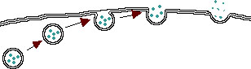

24. When a cell uses a protein to pass a particle through a cell membrane from high to low concentration, it is called _________.
A. facilitated diffusion B. osmosis C. diffusion D. active transport
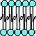
25. The diagram to the right is composed of __________________ .
A. proteins B. cholesterol C. phospholipids D. carbohydrates

26. Which of the following is not a passive transport process?
A. diffusion B. osmosis C. facilitated diffusion D. endocytosis

27. Which cellular process is illustrated in the diagram below?
A. endocytosis B. osmosis C. hydrolosis D. excretion
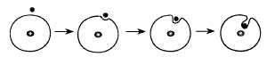

28. The process of osmosis would explain the net movement of water into a cell if the percentage of
A. water was 80% inside the cell and 80% outside the cell
B. protein was 30% inside the cell and 35% outside the cell
C. water was 85% inside the cell and 80% outside the cell
D. water was 80% inside the cell and 85% outside the cell

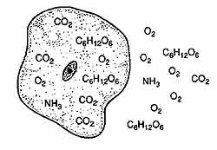
29. The diagram represents a cell in water. Formulas of molecules that can move freely across the membrane are shown. Some molecules are located inside the cell and others are in the water outside the cell. Based on the diagram of molecules below, what would most likely happen to these molecules after a few hours?
A. The concentration of O2 will increase outside the cell
B. The concentration of NH3 will increase inside the cell
C. The concentration of CO2 will increase outside the cell
D. The concentration of C6H12O6 will increase inside the cell

30. What would happen if you place a plant cell in a hypertonic solution?
A. the plant cell will take in water and bust
B. the water will go out of the plant cell and it will shrink.
C. the water will travel in and out of the plant cell.
D. the condition of having a high solute concentration on one side of a membrane will remain constant.

31. Which structure permits the entry and exit of dissolved materials in an animal cell?
A. lysosome B. chromosome C. cell wall D. cell membrane

32. _______________ is the movement of materials from a higher to a lower concentration.
A. active transport B. passive transport C. hydrolysis D. vehicular transport

33. _______________ transport involves processes such as osmosis and diffusion.
A. Passive B. Active C. Mechanized D. Extracurricular

34. The cell or plasma membrane is composed chiefly of two layers of ______________ with globular ______________ floating in these layers.
A. proteins, lipids B. cholesterol, proteins C. lipids, proteins D. endocytosis, exocytosis

35. _______________ transport is the movement of materials from lower concentration to higher concentration as in the processes of endocytosis and exocytosis.
A. Active B. Passive C. Mechanized D. Extracurricular

