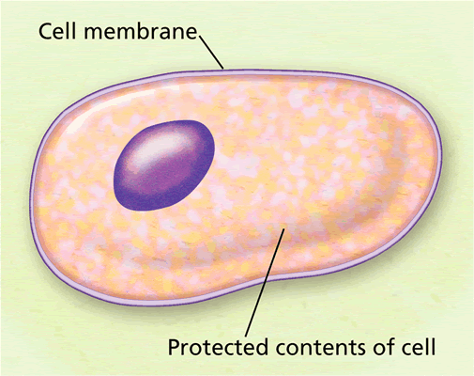
Station #1 – Vocabulary

Directions – Match the Term in Column A with the description in Column B. Write the Capital letter on your answer sheet.

Column A Column B

- Selectively Permeable A. Movement of water from high to low concentration

- Osmosis B. Movement of materials through a cell using energy

- Diffusion C. Means “choosy” as to which substances enter the cell

- Active Transport D. Movement of perfume particles from high to low

- Passive Transport E. The outside protective barrier of a cell

- Cell Membrane F. Equal water or particles inside & outside of cell

- Equilibrium G. Movement of materials through cell without using energy

- Endocytosis H. Type of active transport where cell membrane wraps
around material and brings it into the cell
Station #2 – Soupy Salad

You cut up some ripe strawberries and place them in a bowl. However, you decide they need a little sweetening. Therefore, you sprinkle some sugar on top of the fruit and place the bowl in the refrigerator to chill. A little while later you go to eat your berries but notice that there is a lot of strawberry juice sitting at the bottom of the bowl. Use what you know about osmosis to answer the following.

- Draw strawberries on your answer sheet and illustrate the following:
  - Write “H” to identify where there is a high water concentration.
  - Write “L” to identify where there is a low water concentration.
  - Draw an arrow to indicate how water will flow.

- Now look at your picture and explain why there was juice in the bowl using the words high water concentration and low water concentration.

Station #3 – Watery Worms

A marine biologist has a tank filled with several species of saltwater worms. One day, the scientist decides to clean his tank. He carefully transfers his worms from their original tank to another one filled with freshwater. After cleaning his tank, the scientist is excited to place his marine critters back into their home. However, when he goes to grab the worms he notices that many are puffy and seemed to be swelled with water. Using what you know about osmosis, answer the following.

- Use the picture of the tank and worm on your answer sheet to do the following:
  - Write “H” to identify where there is a high water concentration.
  - Write “L” to identify where there is a low water concentration.
  - Draw an arrow to indicate how water will flow.

- Now look at your picture and explain why the worms swelled up using the words high water concentration and low water concentration.

Station #4 – Crunchy Cucumbers

You have just grown a whole garden of cucumbers and decide that you have enough of this vegetable to make a great summertime snack. You take your crisp cucumbers filled with freshwater and place them in a barrel filled with saltwater. After a few days, you notice your cucumbers have shriveled and lost a lot of moisture. Use what you know about osmosis to answer the following.

- Use the picture of the pickle and barrel on your answer sheet to do the following:
  - Write “H” to identify where there is a high water concentration.
  - Write “L” to identify where there is a low water concentration.
  - Draw an arrow to indicate how water will flow.

- Now look at your picture and explain why the cucumbers shriveled up using the words high water concentration and low water concentration.

- What type of summertime snack did you end up making? Write your answer on your answer sheet.

Station # 5 – Wandering Water Molecules

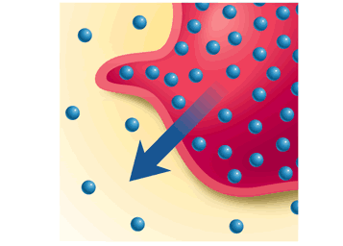
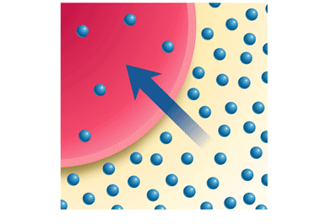
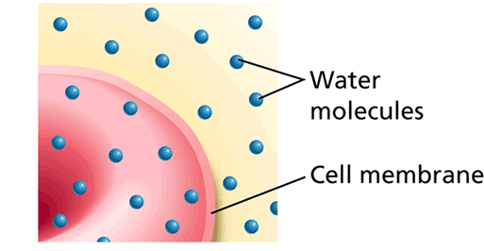

Diagram C

Diagram B

Diagram A

- Look at Diagram A. The red blood cell is in a state of equilibrium. What does this mean? Explain on your answer sheet.

- Look at Diagram B. Was the red blood cell placed in freshwater or saltwater. Write the answer on your answer sheet.

- Look at Diagram C. Was the red blood cell placed in freshwater or saltwater. Write the answer on your answer sheet.

- The above diagrams show how water is moving through a cell. What term describes the movement of water from high to low concentration? Write the answer on your answer sheet.

- Does this transport process require energy? Write yes or no on your answer sheet.

