Bozeman Video Guide:
Pedigree Analysis

- On a pedigree, females will always be ___________________ and males will always be _________________.

- What does a horizontal line between a circle and a square mean?

- Affected individuals in the trait you want to study will be _______________________________.

- Is the following pedigree of an autosomal dominant or autosomal recessive trait?
Fill in the pedigree and explain your answer (in detail):
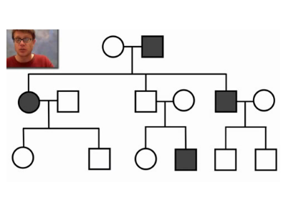
Dominant or recessive? Explain your answer.
Fill in by assuming that it is a dominant trait:

Fill in by assuming that it is a recessive trait:

