Scientific Method
Important Vocabulary Words:
In order to form theories and explore the science world we must ask questions and form ___________ (backed by facts).
What is a testable hypothesis?________________________________________________________________________
Control____________________________________________________________________________________________
Types of Data:
Qualitative Data involves ________________________ Example: ______________________________________
Quantitative Data involves _______________________ Example: ______________________________________
Variables:
Independent____________________________________________________________________________________

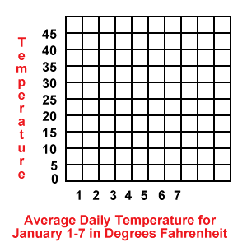
Dependent Variables______________________________________________________________________________
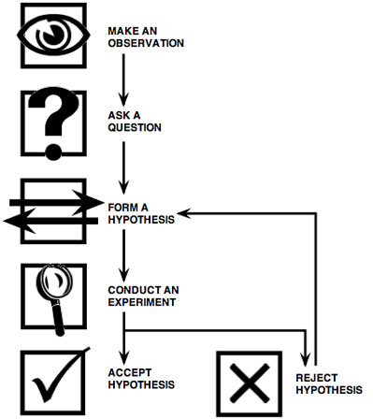
The Steps of the Scientific Method:

After you have formed a conclusion, you must _____________________ to verify/make sure your conclusion is correct.

Amanda is testing how different amounts of caffeine affects the heart rate of rats. Below is the data she collected.
Group | Amount of caffeine | Heart rate (bpm)
A | 0 mg | 190
B | 50 mg | 225
C | 100 mg | 260
Identify each of the following:
1. Control group – ______________________________________________________________________
2. Experimental groups – ____________________________________________________________________
3. Independent variable – ___________________________________________________________________
4. Dependent variable – ____________________________________________________________________

Practice EOC Questions:
- Which experimental procedure would best determine the effectiveness of a medicine for preventing a certain disease in mice?
A Treat 50 mice with the medicine and 50 mice with a harmless substance and then expose all 100 mice to the disease.
B Expose 100 mice to the disease and then treat all 100 mice with the medicine.
C Expose 100 mice to the disease and then treat 50 of these mice with the medicine.
D Treat 10 mice with the medicine and 90 mice with a harmless substance and then expose all 100 mice to the disease.

- A student conducted an original, well-designed experiment, carefully following proper scientific procedure. What must happen next, in order for the conclusions to be generally accepted?
A The experiment must be conducted by a scientist.
B The experiment must support the original hypothesis.
C The experiment must contain several experimental variables.
D The experiment must be repeated to verify the reliability of the data.

- A student heats crushed liver in a test tube with a hot water bath. What type of safety equipment
must be used to do this activity?
A safety goggles B fire extinguisher C plastic gloves D a rubber stopper on the test tube

